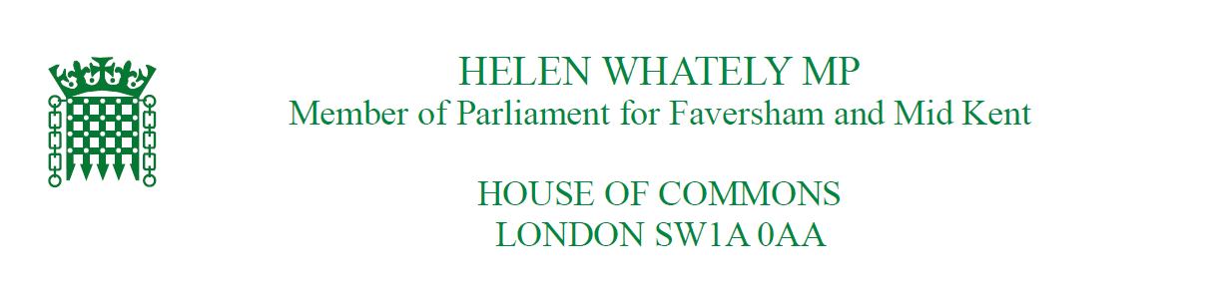

Press Release

Clear message from voters in Faversham and Mid Kent

Statement from Helen below.

“I am delighted to have been re-elected as Member of Parliament for Faversham and Mid Kent. Being an MP is a huge responsibility and I’m humbled that so many people have put their trust in me once again.

“Nationally, a Conservative majority government means we can take the country forwards and start to heal some of the divisions in our society. We can now look ahead to the New Year with a Parliament that will deliver on people’s hopes and make life better for everyone.

“It’s a majority that means we will be able to get on with Brexit, and get on with tackling all the other priorities that have been talked about during the campaign, from the NHS to schools, policing, the environment and infrastructure.

“Here in Kent, we need better access to GPs, better mental health services, less traffic and less pollution, safer streets, and even better schools. These will continue to be my priorities as your MP.

“At a time when politics can be nasty, I am truly grateful for the kindness and messages of support I have received from people during this campaign. I hope we can all agree on the need to cut out the abuse and be nicer to each other in politics.

“Whilst my majority has increased at this election, I know there are many different views in this constituency. I will continue to work hard to represent everyone in our community and do the right thing for Faversham and Mid Kent.”

Ends...

